|  |  |
| --- | --- |
| |  | | --- | | Image | |
| **CTB AND CO. 2020**  **THE COMEBACK GUIDE** |

|  |  |
| --- | --- |
| |  | | --- | |  | |

Hi All

Well I am not going to lie, it has taken me a while to recover from the shock of the forced closure of nearly all of our great partners’ restaurants, cafés, pubs and clubs.

Like you, we are really hurting, and we too would like to know how long this beast of a virus is going to last. But those who know me would have to agree that I am not one to let a virus break me so I want to make sure we are all ready to bounce back.

I’ve decided to use this time instead to make improvements and putting plans in place so that when you’re ready to open your doors, you will be prepared.

I know your clientele has drastically reduced or been completely decimated because we can’t go out, but we need to start planning now while we have this precious commodity called “time” (which we have all complained of never having prior to now).

So what we are going to do when it is finally over and you can open your doors again?

**MONEY**

Money is likely to be tight for a few years so we (chefs, bar managers, purchasing officers) need to take this on board and think about what is it that will make your offering special and ultimately make customers want to spend it at your venue.

I understand chefs love the creative side more than anything (let’s face it – it’s the fun stuff) but now there is a major change. More than ever you will have to focus on making money out of every dish - not just one or two.

I may sound like a broken record but think of menu items that are easy to make, have lower wage costs and are cheap to produce. The customer must also see value for money - we don’t want to rip them off as they will not come back.

Staff – let’s get used to the idea that they aren’t all likely to be coming back and our workplaces will differ from here on in. There is simply not enough money in the short term to justify them all being rostered on, so you must start considering options to make or buy products.

As chefs love to create, many will find it difficult to be objective when deciding whether to stop preparing or making an item inhouse or buy it in already done.

The arguments often go:

* *‘We’ve got to do it ourselves because hand-made and in-house tastes better.’* The reality is that there are many pre-made, pre-cut or portion-controlled products on the market that are of equal or higher standard than what you can consistently produce in house.
* *‘My apprentices won’t learn anything if I get my meats in portion controlled.’* It is frustrating to many chefs that the skills of butchering, baking, etc. seem to be a dying art within commercial kitchens. Commercial reality has meant that the erosion of profit margins and the lack of staff — skilled or otherwise — has presented business opportunities for companies that can produce product lines that are competitively priced for the food service market.
* *‘The customers expect that we do everything ourselves.’* Generally, customers are more interested in the consistency of your service and product. If they cannot tell the difference between in-house production and bought in, it should come down to what is the best business decision.
* And lastly, the number one response — *‘I’m selling out if I buy it in. My integrity is being compromised if I buy it in.’* If you’re happy to work for free, go right ahead!

I’d like to use the example of making a cake:

|  |  |
| --- | --- |
| Reason for making:   * It’s cheaper. * The customers expect us to make it. * We’ve got to do it ourselves because it tastes better. * I won’t be able to teach my staff how to make it. * I’m selling out if I buy it in. | Then ask yourself:   * Have you costed making and buying each cake? * Does every chocolate cake you make taste the same very time? * Do you burn or waste any of the cakes you make before the customer sees them? * What is the customer looking for in buying a piece of cake? * How hard is it to produce the cakes in your kitchen? * Are you set up to make cakes in your kitchen? |

I understand these arguments but in this type of analysis, all costs of each alternative must be calculated, and other factors should be considered before the decision is made.

Answering the above questions will help you decide where to make an item in-house or buy it in already done. I know that many chefs may find this hard, however in the current age of the financially responsible chef, the decision should be the best for the business. *Let’s have a closer look*

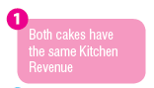

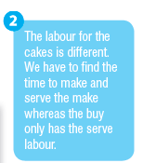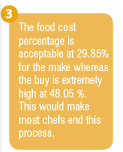

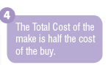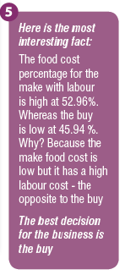

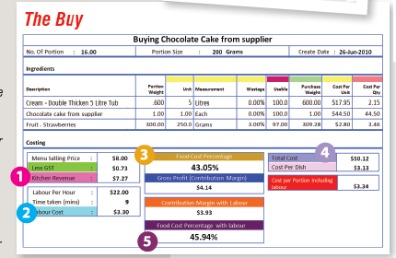

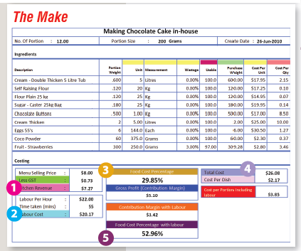

What we are trying to do in this type of yield test is to remove the emotion from the decision of whether to make or buy. A financially responsible chef would do this yield testing for all products that they wish to make and then make the appropriate business decision. As we all know it's not just about cooking now, it's all about making money.

**SUPPLIERS**

They too are hurting as much as you, possibly more. They are most likely still waiting to be paid for February and March.

You need, more than ever, to have a relationship with them. They want to help and they are a wealth of knowledge about their products.

Effective food control is a basic method for enhancing the potential for success of any food preparation establishment. You need to follow well-established *food control* procedures for handling food at all stages of the operation. It is essential to keep good records in order to minimise waste and maintain profitability.

The aim of an effective purchasing system is to **obtain the right product at the right price for the right job**.

In addition, the product should be:

* An appropriate quality for the dish you are creating.
* Purchased in the correct quantity so you don’t have too much but also so you don’t run out.
* Purchased at the right time from the best supplier.

The new vernacular in 2020 will be **PRODUCT FOR PURPOSE**.

* What are you buying this product for?
* What are you going to do with it?
* Will the customer see it in its original state?

For example, most fruit and vegetable wholesalers carry at least three different grades of avocadoes.

|  |  |
| --- | --- |
| * They all have a different cost and a different purpose. | * The variable cost can be $20 a tray |
| * The cheap ones are good for smashed / mashed on toast or in a guacamole. | * The more expensive one is for use where the customer will see the final product, like a chicken and avocado salad. |

Good relationships with suppliers cannot be over-emphasised. The relationship needs to be an equal partnership as both you and your supplier are in business to make money and need each other to do it.

Make time available, when appropriate, to see suppliers. Talk to them regularly about:

* New products.
* What you need to do with that product.
* Market trends.
* Possible shortages.
* Specials.
* Discounts.

Remember in choosing a supplier, you are building a long-term relationship…. not a one-night stand!

The food operator’s obligation to the supplier are to:

* Understand that they are a business and are also in business to make money.
* Pay the account on due date.
* Order efficiently therefore reducing cost/price.
* Treat them with respect, professionalism and understanding.

Ring them and start the conversation. Yes, it’s time for chefs to look at the books and while I know we all hate paperwork , if you take this time now to review what I have mentioned you will be on a far better path to keep your doors open once we return to the new normal.

**STAFF**

We need to be leaders. Our staff will be fragile; they will need support and mentoring. Executive chefs and head chefs may seem expensive, but the great ones will help a business survive. It’s also important that we don’t make rash decisions, make sure every action is thought through and look at what the ramifications may be if we implement these changes.

Training and educating your staff RIGHT NOW is one of the most important jobs you can undertake. Consider where you and your staff need to improve and use this time wisely!

**YIELD**

The term ‘yield’ refers to the net weight or volume of a food item after it has been processed to a particular stage.

|  |  |  |
| --- | --- | --- |
|  |  | CTC-2675-image4.jpg |
| **Purchased Weight**  What was purchased from the butcher. | **Trimmed Weight**  Processed and ready to cook or be sold. | **Cooked Weight**  Final weight of product to be served to customer. |

Yield refers to the amount of saleable food obtained from a raw product

So consider:

* What product will this give you?
* How much does 1 kilogram of frozen prawn meat provide when thawed?
* What useable product do you get from an A10 tin of pineapple when drained?
* What is the real cost per kilogram of an eye fillet or porterhouse when you trim? Can you use these off-cuts for another dish?

Now is a great time to look at all the yield results for products on your menu.

**RECIPE CARDS**

For those who know us at Cooking the Books, we do drum into you (quite a bit) about creating recipe cards. We still strongly believe that it is essential to have recipe cards for every item you create.

**Why?**

Well, not just for the consistency in look, but because it forces you to use the same ingredients, understand dietaries and allergens, but most importantly it ensures that the taste is universal, regardless of who made it.

The main aim of a standard recipe is to provide a consistent product. In other words, a standard recipe is the logical method of controlling quality and quantity.

Now could not be a greater time to create all these recipes instead of sitting at home looking at the walls. Some key things to consider:

* Make sure your ingredients and preparation are clear. If you put 2 kg of onion on a recipe card - what does that actually mean? Is it 2 kg of onion or 2kg of diced onion? I’m asking this question as there is a big difference in required quantity as over 7% of a whole onion goes into the bin.
* Remember who you are writing a recipe card for and pretend it is for someone that has never made the dish. Provide as much information as possible.
* Ask your kitchen staff for special ideas. Get them to prepare a recipe card as this will encourage them to take ownership of that menu item.
* When you and the team are back in the kitchen, make a competition out of it. This will not only be fun for the team but will have them invested in the business. An example could be who sold the most of their special and who made the most money overall based on gross profit percentages.



**RECIPE COSTING**

Yes, I am on repeat!

The most important thing to do with your menu is **COST EVERYTHING.** Not just parts of the menu - every dish, every recipe down to the last grain of salt!



A standard cost sheets allows you to work out the total cost of a recipe, the food cost % and therefore generate an appropriate selling price.

This, more than ever is a kitchen and business necessity. Below we have provided two links for you to begin this process:

**Excel based costing sheet**

[**Free 30-day trial to Cooking the Books program**](https://web.cookingthebooks.com.au/Default/Login)

By now, most chefs will be thinking I am trying to take away their creative flare and excitement by creating their own dishes.

This is not true. It is only common sense that new recipes be tested and calculated correctly before they are recorded onto standard recipe cards, since the recipe card forms the basis of the food control system.

What I am suggesting is that each dish must follow a process:

* Create a dish using your flare and your knowledge.
* Make a recipe card so it can be replicated.
* Cost each ingredient and get a final food / recipe cost.
* Get staff to taste and provide feedback.
* Adjust the recipe including costing.
* Put it on your menu or trial it as a special to ascertain popularity.

**MENUS**

The menu is key to any organisation and establishment.

A menu is more than just a list of food with prices.

It is a reflection of your restaurant style and concept.

Your menu ultimately determines the types of customers you will attract, the employee skills that are necessary, the equipment you will need and the sales / profit your restaurant will generate.

Keep this in mind when shutdown regulations are lifted, and when we return to business as usual consider reviewing your menu using the following principles:

* Keep it simple and small.
* Menu items need to be versatile.
* Easy to prepare.
* Simple to read format for customers.
* Manageable for your kitchen size and staff to deliver.
* Offer specials that reflect the season, using available produce.
* Every dish has a recipe card and is fully costed.
* And most importantly, keep it original.

Remember –

The more dishes you have - the more staff you need.

The more staff you need - the more prep you have.

The more prep and staff you have - the more costs you have.

Also consider

* Providing a well-balanced menu and avoid repetition as this signifies a good understanding of food knowledge. This should be the main objective when planning a menu and includes consideration of colour, ingredients, flavours, textures and cookery methods.
* First impressions are important as we “eat with our eyes”. Foods should look natural & appeal to all senses.
* Consider the colour and shape of foods as well as the height.
* Balance is important on the plate or platter.
* Texture can be visual - it is the mouth feel or coercion of when it is handled.
* Consistency and variety is important and it is achieved by using a variety of fresh, raw and cooked ingredients.

So, is your menu in 2020 **practical**?

* Can the type of meals be prepared and served?
* Is the type of kitchen facilities and equipment available?
* Do you have the skills and capabilities of the kitchen staff?
* Do you have the type of service area, number of meals (covers) and courses to be served?
* Customers may still be nervous about eating out for a while, therefore is your menu versatile for take-away?
* Consider popular trends

|  |  |  |
| --- | --- | --- |
| Cuisines - Middle Eastern, West African, Asian – Vietnamese, Korean, etc. | Unique social experiences - let the customer be involved | Reducing waste and limiting food footprint |
| Instagram worthy food | Transparent ingredients | Healthy options |
| Buying local | Flexitarian | Textural |
| Sustainable | Lots more cauliflower (please 🙌) | Expansive kids menus |

**CONCLUSION**

For those of you who are reading about Cooking the Books for the first time, we are here to help you.

We have looked at the totality of the industry and understand the current pain. So, for this reason, we are offering potential customers a heavily reduced subscription fee while the shutdown regulations are in place.

Let’s call it our Corona special.

[](https://web.cookingthebooks.com.au/Default/Login)

and enter promotional code: **Corona**

Please reach out if you need help, ideas or support and together we will get through this stronger than ever.

Good luck chefs and now, it’s time to get on with it!